**Section11**

CREATE TABLE employees (

employee_id NUMBER

);

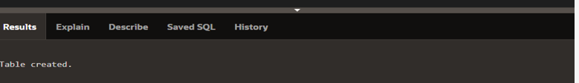

BEGIN

INSERT INTO employees (employee_id) VALUES (1);

INSERT INTO employees (employee_id) VALUES (2);

INSERT INTO employees (employee_id) VALUES (3);

INSERT INTO employees (employee_id) VALUES (4);

INSERT INTO employees (employee_id) VALUES (5);

COMMIT;

END;

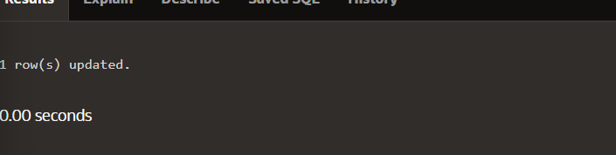

CREATE OR REPLACE PACKAGE curs_pkg IS

CURSOR emp_curs IS SELECT employee_id FROM employees

ORDER BY employee_id;

PROCEDURE open_curs;

FUNCTION fetch_n_rows(n NUMBER := 1) RETURN BOOLEAN;

PROCEDURE close_curs;

END curs_pkg;

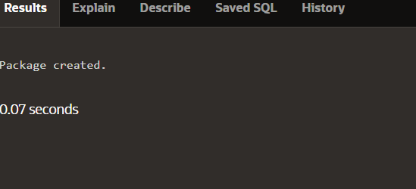

CREATE OR REPLACE PACKAGE BODY curs_pkg IS

PROCEDURE open_curs IS

BEGIN

IF NOT emp_curs%ISOPEN THEN OPEN emp_curs; END IF;

END open_curs;

FUNCTION fetch_n_rows(n NUMBER := 1) RETURN BOOLEAN IS

emp_id employees.employee_id%TYPE;

BEGIN

FOR count IN 1 .. n LOOP

FETCH emp_curs INTO emp_id;

EXIT WHEN emp_curs%NOTFOUND;

DBMS_OUTPUT.PUT_LINE('Id: ' ||(emp_id));

END LOOP;

RETURN emp_curs%FOUND;

END fetch_n_rows;

PROCEDURE close_curs IS BEGIN

IF emp_curs%ISOPEN THEN CLOSE emp_curs; END IF;

END close_curs;

END curs_pkg;

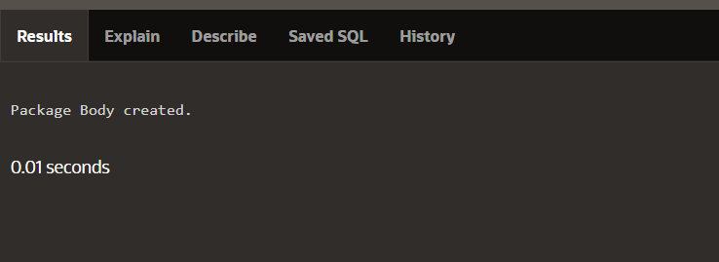

DECLARE

v_more_rows_exist BOOLEAN := TRUE;

BEGIN

curs_pkg.open_curs; --1

LOOP

v_more_rows_exist := curs_pkg.fetch_n_rows(3); --2

DBMS_OUTPUT.PUT_LINE('-------');

EXIT WHEN NOT v_more_rows_exist;

END LOOP;

curs_pkg.close_curs; --3

END;

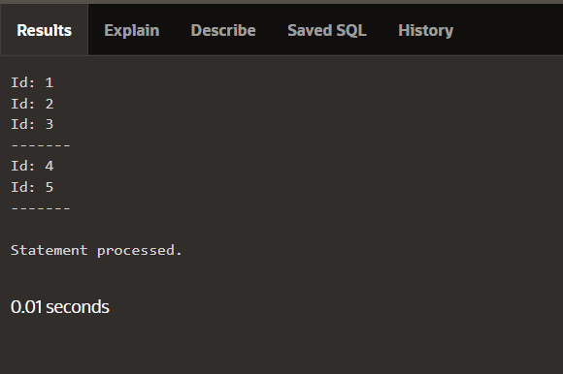

BEGIN

DBMS_OUTPUT.PUT_LINE('The cat sat on the mat');

END;

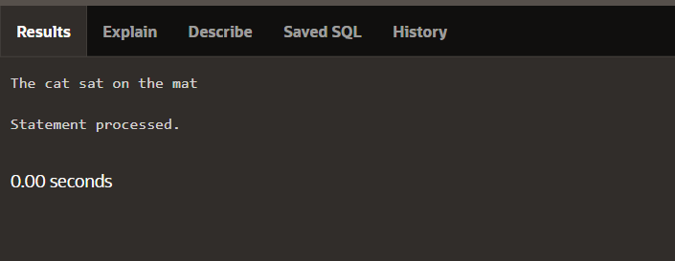

BEGIN

DBMS_OUTPUT.PUT('The cat sat ');

DBMS_OUTPUT.PUT('on the mat');

DBMS_OUTPUT.NEW_LINE;

END;

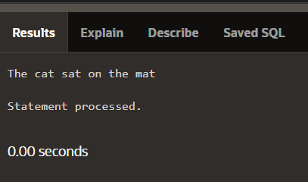

DECLARE

v_bool1 BOOLEAN := true;

v_bool2 BOOLEAN := false;

v_number NUMBER;

BEGIN

IF v_bool1 AND NOT v_bool2 AND v_number < 25 THEN

DBMS_OUTPUT.PUT_LINE('IF branch was executed');

ELSE

DBMS_OUTPUT.PUT_LINE('ELSE branch was executed');

END IF;

END;

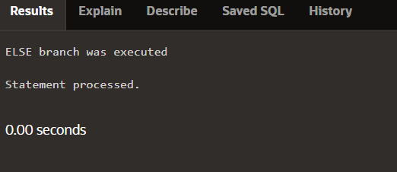

CREATE OR REPLACE PROCEDURE do_some_work IS

BEGIN

DBMS_OUTPUT.PUT_LINE('string');

END;

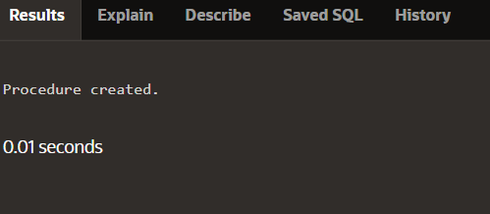

CREATE OR REPLACE PROCEDURE do_some_work

( p_output OUT VARCHAR2)

IS BEGIN

p_output := 'string';

END;

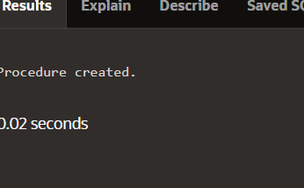

CREATE SYNONYM UTL_FILE FOR SYS.UTL_FILE;

CREATE OR REPLACE FUNCTION FOPEN (

location IN VARCHAR2,

filename IN VARCHAR2,

open_mode IN VARCHAR2

) RETURN UTL_FILE.FILE_TYPE;

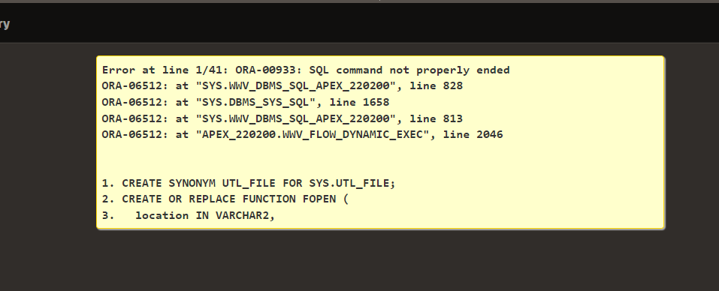

PROCEDURE read(dir VARCHAR2, filename VARCHAR2) IS

file UTL_FILE.FILE_TYPE;

BEGIN

IF NOT UTL_FILE.IS_OPEN(file) THEN

file := UTL_FILE.FOPEN (dir, filename, 'r');

END IF; ...

END read;



CREATE OR REPLACE PROCEDURE send_mail_with_text

(p_text_attachment IN VARCHAR2)

IS BEGIN

UTL_MAIL.SEND_ATTACH_VARCHAR2(

sender => 'me@here.com',

recipients => 'you@somewhere.net',

message => 'See attachment',

subject => 'Useful document for our project',

attachment => p_text_attachment,

END send_mail_with_text;

